Module 1 Critical Thinking

Alex Zelmanowicz

Colorado State University Global

Professor Farr

CSC 500

11 February 2024

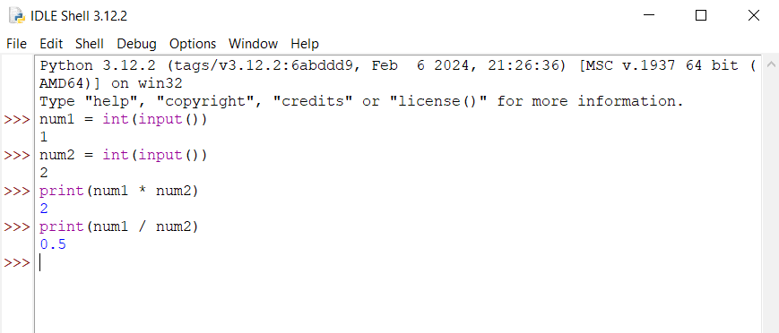

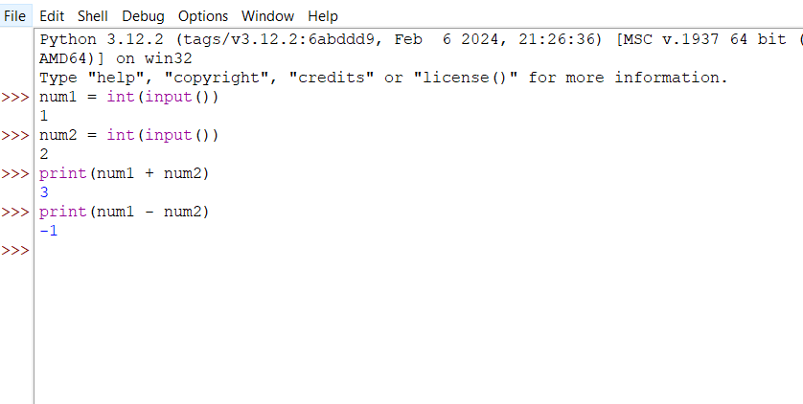

**Part 1 PseudoCode:**

1. Input first number for num1.

2. Read number as 1.  
3. Input second number for num2.

4. Read number as 2.

5. Add num1 and num2.

6. Display addition value.

7. Divide num1 by num2.

8. Display division value.

9. End

**Part 2 PseudoCode:**

1. Input first number for num1.

2. Read number as 1.  
3. Input second number for num2.

4. Read number as 2.

5. Multiply num1 and num2.

6. Display multiplication value.

7. Divide num1 and num2.

8. Display division value.

9. End

**Part 1:**

>>> num1 = int(input())

1

>>> num2 = int(input())

2

>>> print(num1 + num2)

3

>>> print(num1 - num2)

-1

**Part 2:**

>>> num1 = int(input())

1

>>> num2 = int(input())

2

>>> print(num1 * num2)

2

>>> print(num1 / num2)

0.5